TFO
Form Design Using Microsoft Access

LAb Objectives
- Understand the Form Wizard.
  - Choose Table or Query.
  - Choose Form Layout.
  - Modify Properties.
  - Create Subforms.
- Apply Form Design Guidelines.
- Use the Form Wizard to Create a Form.

Access Forms
Forms display and allow entry to records in a table. A form provides a more user-friendly way than either tables or queries for users to enter and edit information. The use of forms was explored in Lab 1. You may want to review that lab to refresh your memory. In this lab we will learn how to create forms.

Creating a TABULAR With the Access FORM Wizard
As with reports, Microsoft Access provides a wizard that leads you through form creation and does a lot of the work for you. You don't have to use the wizard, but many Access developers find it faster in the long run to let the wizard create the form and then manually modify it. That is what we will do. Do the following:

- If you have not already done so, launch Microsoft Access and the special version of the Northwind database that works with these labs.
- In the menu at the top of the window, click Create.
- Click the dropdown beside the More Forms icon in the toolbar. Then click Form Wizard.
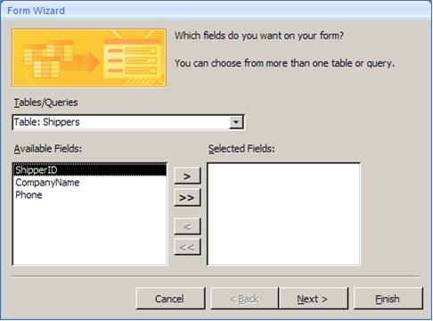
- You will see the wizard dialog box shown here. Let's assume we want to build a form on the Shippers table. From the Tables/Queries dropdown box, select Table: Shippers.
- You will then see the fields of the Shippers table in the Available Fields box. Move them all to the Selected Fields box using the buttons in the middle of the screen.
- Click Next.
- The form design wizard then offers the four kinds of layouts shown here. They are each illustrated and described below.
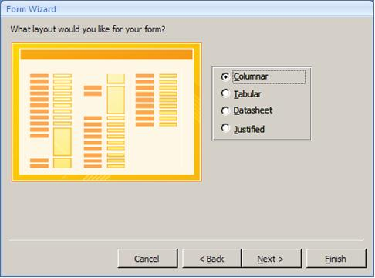

Columnar Forms  - Text boxes appear in a column down the screen but can be moved.  - Shows one record on the screen at a time  - Used most often |  | 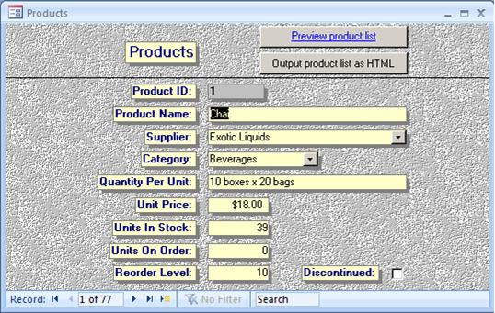
Tabular Form  - Text boxes appear in a row across the screen  - Shows multiple records on the screen at a time.  - Used for tables with few fields. |  | 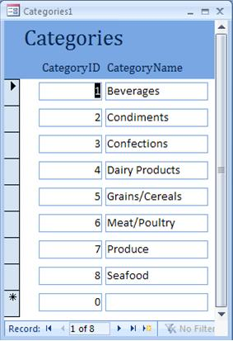
Datasheet Form  - Text boxes appear in rows and columns as in a table.  - Shows multiple records on the screen at a time | 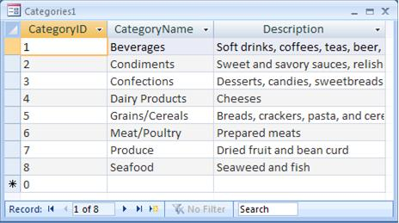
Justified Form  - Text boxes are spread across the screen with labels above the text boxes  - Shows one record at a time  - Used to duplicate the look of paper forms | 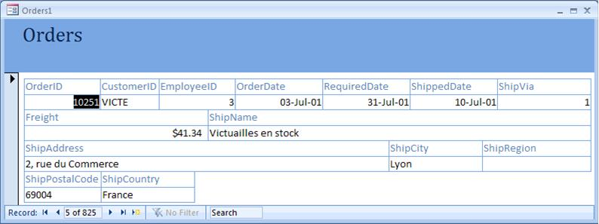

- For our wizard, select Tabular. The Shippers table has few fields and few records. It will work well as a tabular form.
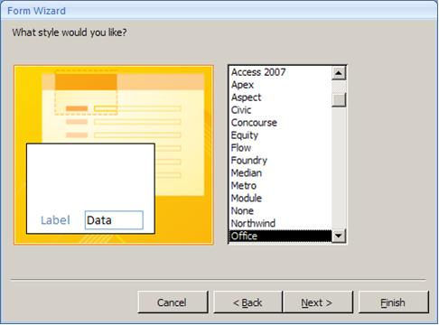
- Click Next.
- Next you can select a style for your form. For our purposes, highlight Office and click Next.
- On the final screen you will be asked to enter a name for the form. Use the default name of Shippers and click Finish.
- The wizard-built form will appear as shown next.

Form View and Design View

There are two ways to view forms. You can switch between the views by clicking the Design View icon and the Form View icon in the bottom right of the screen. Form View (shown below) is how users see the form. Form View is used to enter data.

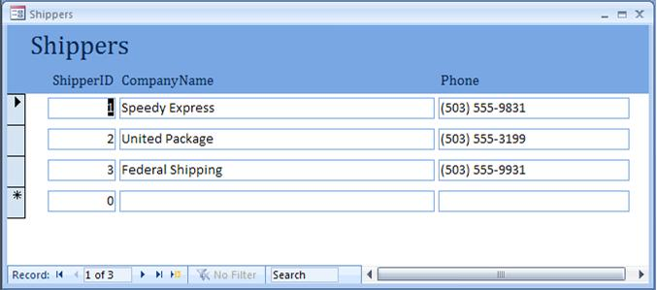

- Click the Deisgn view icon to switch to Design View.
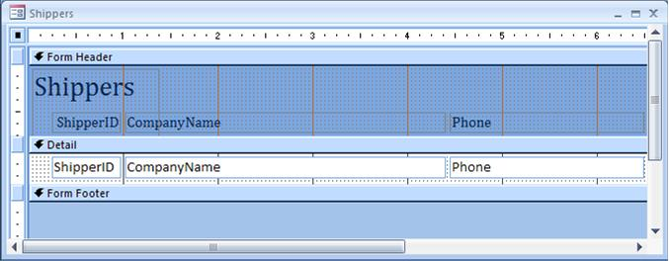

Design View is used to modify the form’s structure. Notice that for each field (ShipperID, CompanyName, and Phone) there is a one object with that name in the Form Header and one object with that name in the Detail band. The objects in the Form Header are label objects that display constant text to identify the field to the user. The objects in the Detail band are text boxes that display the actual data and allow users to make entries.

- Close the form and save your changes.

Creating and Modifying a Columnar Form
- In the menu at the top of the window, click Create.
- Click the dropdown beside the More Forms icon in the toolbar. Then click Form Wizard.
- Base this form on the Products table and select all fields for the form.
- Make this form a Columnar form using the Office style.
- Name the form "Edit Products." When the form wizard finishes, it should show a form similar to what is shown here.
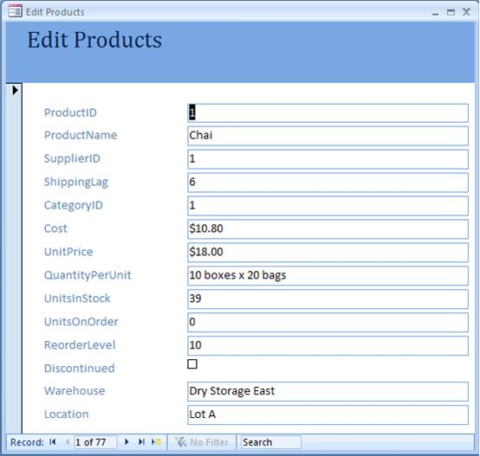

We will make several modifications to this form to make it more useful to users.

Resizing Controls (Part 1)
- Switch to Design View.
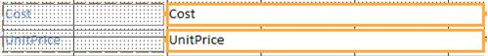
- Our first change will be to resize the Cost and UnitPrice text boxes, which are currently big enough to hold costs in the trillions of dollars. Click on the Cost text box. Then hold down the Shift key and click on the UnitPrice text box. Both should now be selected as shown here.
- You will notice the little buttons on each side of the text boxes. These are used to resize it.
- Position the mouse over the button at the right end of either text box. The mouse cursor should change to a two-headed arrow.
- Hold down the left mouse button and drag the mouse to the left to make the text boxes horizontally smaller. Drag it until the text boxes are one inch in width.
You'll notice that all other text boxes change to that same size. That is not what we want. So undo that resizing by clicking the undo button at the top of the screen.

Removing a Control Layout
The sizing of all the form controls together is caused by the fact that the Form Wizard has applied a control layout. To remove it, do the following:

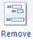
- Press Control-A to select all the controls on the form.
- Click on Arrange in the menu at the top of the screen.
- Click the Remove button in the Control Layout group.

Resizing Controls (Part 2)
With the control layout removed, let's try resizing again.

- Click on the Cost text box. Then hold down the Shift key and click on the UnitPrice text box. Both should now be selected as shown here.
- Position the mouse over the button at the right end of either text box. The mouse cursor should change to a two-headed arrow.
- Hold down the left mouse button and drag the mouse to the left to make the text boxes horizontally smaller. Drag it until the text boxes are one inch in width.

Note
If you want to make small adjustments to the size of a control on either a form or a report, you can hold down on the Shift key while pressing the appropriate arrow keys.

- Size the other text boxes on the form so that it resembles what is shown here. There is an invisible box are the Discontinued checkbox that should be sized to the size of the Warehouse text box.
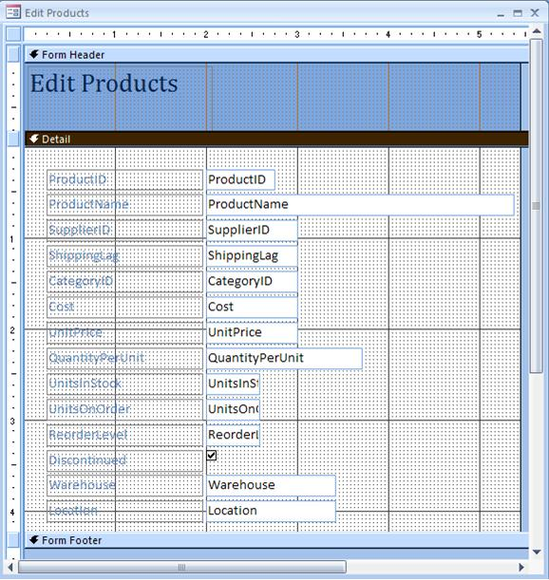

Moving Controls
- Click on the Location field text box. Hold down the Shift key and click on the Warehouse text box and the Discontinued text box.
- Position the mouse on any of the text boxes other than on one of the sizing buttons. The mouse cursor should change to a four-headed arrow. When you see this, you can move the selected controls together.
- Access displays move handles for both controls, as well as the sizing handles for the
- Hold down on the left mouse button and drag the controls to the right of UnitsInStock, UnitsOnOrder, and RecorderLevel as shown here.

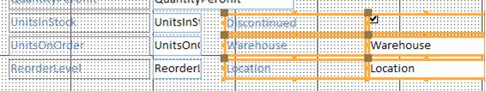

- You can resize the form to fit the controls. Position the mouse at the bottom of the form. When it turns into a two-headed arrow, you can drag up with the mouse to make the form shorter. Position the mouse at the right side of the form. When it turns into a two-headed arrow, you can drag to the right to give your controls a little margin on the form.

Aligning Controls
Let's make sure the Discontinued checkbox lines up vertically with the UnitsInStock textbox.

- Click on the Discontinued checkbox. Hold down the Shift key and click on the Discontinued label, the UnitsInStock text box, and the UnitsInStock label to select all of them together.
- Click on Arrange in the menu at the top of the screen.
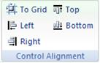
- Click on the Top icon in the Control Alignment section.
- Access always moves the selected objects to the rightmost or leftmost or topmost or bottommost it can (i.e. if you click on Left, it will move all objects other than the leftmost object to be aligned with that object).
- Repeat the above process to align the Warehouse text box and label with the UnitsOnOrder text box and label and to align the Location text box and label with the ReorderLevel text box and label.

Adding a Box and Setting its Properties
There are many things we can add to enhance the form. Sometimes a simple thing like a box around a group of controls can group them in the users mind and add to understanding. Let's draw a box around the UnitsInStock, UnitsOnOrder, and ReorderLevel text boxes.

- Click Design on the menu at the top of the screen.
- Click on the Rectangle control in the Controls section of the toolbar.
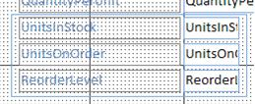
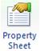
- Position the mouse in the form just under the bottom left corner of the QuantityPerUnit Label. Hold down the left mouse button and draw the rectangle to the right and down until it surrounds the UnitsInStock, UnitsOnOrder, and ReorderLevel text boxes and labels. The result should look like what is shown here.
- As with reports, every object on a form has properties. Select the box you just drew and click on the Property Sheet icon.
- Click into the Special Effect property line. A dropdown arrow will appear. Click on the dropdown arrow. Select Sunken. This will give your rectangle a sunken appearance.
- Click the Form View icon to view the results (shown on the next page).

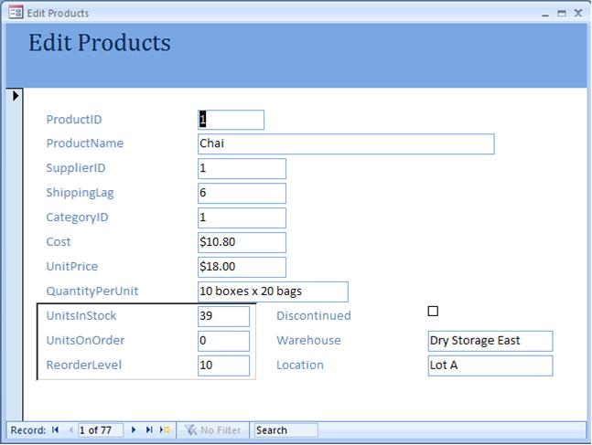

Using Combo Boxes to Lookup Data
The SupplierID on our Edit Products form represents the supplier from whom each product is purchased. The SupplierID numbers is a foreign key that relates to the primary key of the Suppliers table. But to a human user, seeing and entering suppliers by the full company name would be much more useful.

Combo boxes provide a dropdown list of options to use in entry. They are easier to use than text boxes both for entries that have a fixed number of entry options (“Male,” “Female”) and entries that “look up” data from other tables.

A combo boxes actually works with two tables. It looks up data from a lookup table (Suppliers, for instance) and saves that information to the current record in the main table (Products). This is like when you are filling out your taxes. You look up the amount of tax you owe from a tax table in the back of the book and write it on your main tax form. As you work with combo boxes remember that they often work with two tables.

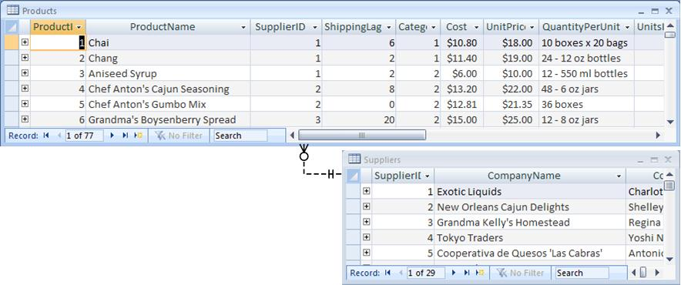
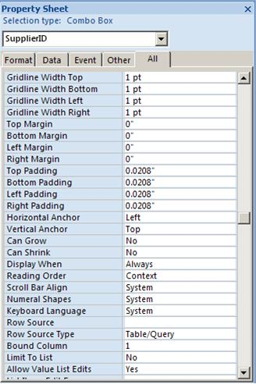
- Click on the Design View icon.
- Right-click on the SupplierID text box and select from the pop-up menu Change To | Combo Box.
- With the new combo box selected, click the Property Sheet icon to view its properties. Note that the Control Source property of this combo box is the SupplierID field of the Products table. We need to keep this as it is so that our combo box selection will be saved back to this field in the Products table.
- The key property to set is the Row Source. This determines what appears in the dropdown list. The Row Source property can be the name of a saved query or an SQL SELECT statement.
- Right-click on the Row Source property line and select Zoom from the pop-up menu. This will open the Zoom box where you can type an SQL statement.
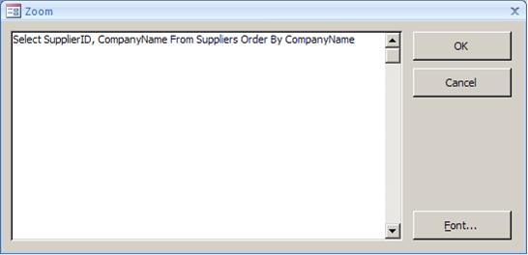
- Type the SQL shown here and click OK. As you can tell from the SQL, it will select two fields from the Suppliers table. The first column is the SupplierID. We have to include that because it is the primary key field in the Suppliers table that matches the SupplierID foreign key field in the Products table. The CompanyName field is included for the benefit of human users who do not know the SupplierID numbers.
- In the Property Sheet, set the Column Count to 2 because the Row Source will return two columns.
- Also in the Properties dialog box, set the Column Widths to 0;2. What does this do? This sets the widths of each column in the Row Source, with each column width separated by a semi-colon (;). We have set the width of the SupplierID column to 0, essentially hiding it from the user. We have set the width of the CompanyName column to 2 inches.
- Set the Width property to 2.1. We are adding .1 inches to allow for the dropdown arrow and scroll bar.
- Click the Form View icon to see how the new combo box works. Click the dropdown arrow on SupplierID.

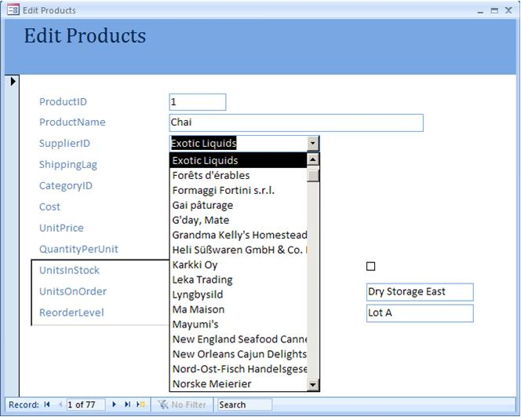

Because we hid the SupplierID column the user no longer sees the SupplierID numbers either in the dropdown list or in the reported data on the top line. But the SupplierID number is still tracked by Access and recorded in the Products table.

Let's review what this combo box is doing. Our overall Edit Products form is editing the Products table. One of the fields in the Products table is SupplierID. We have changed the SupplierID text box to a combo box that looks up and displays the CompanyName from the Suppliers table along with the hidden SupplierID field. Now the user can view the list of CompanyNames from the Suppliers table, select one, and have its SupplierID number placed into the SupplierID field of the Products table. The combo box looks up values in one table for entry into another table.

- Click the Design View icon.
- Click on the SupplierID label (to the left of our combo box) to select it.
- Open the Property Sheet box and change the Caption property from SupplierID to Supplier. This will look better since the combo box does not display SupplierIDs.
- Now repeat this whole process for the CategoryID text box. Change it to a combo box. Set its Row Source to view the CategoryID and CategoryName from the Categories table. Set the Column Width of the CategoryID dropdown column to 0. Use trial and error to find the best Column Width for the CategoryName column and for the overall combo box. Finally, edit the Caption of the CategoryID label.
- Close the form and save your changes.
Using Sub-Forms
When you create tables, it is not uncommon to have two tables that work together. For instance, in Northwind the Orders table is closely related to the Order Details table. The Orders table holds general information about the order (such as, the CustomerID, OrderDate, etc.) while the Order Details table holds detailed information about each item that was ordered on a particular order. Using sub-forms we can combine both these tables into one form.

- In the menu at the top of the window, click Create.
- Click the dropdown beside the More Forms icon in the toolbar. Then click Form Wizard.
- Base this form on the Orders table and select all fields for the form.
- Make this form a Columnar form using the Officer style.
- Name the form "Edit Orders."
- Switch to Design View, remove the control layout on the controls, and move the text boxes until they resemble the screen below.
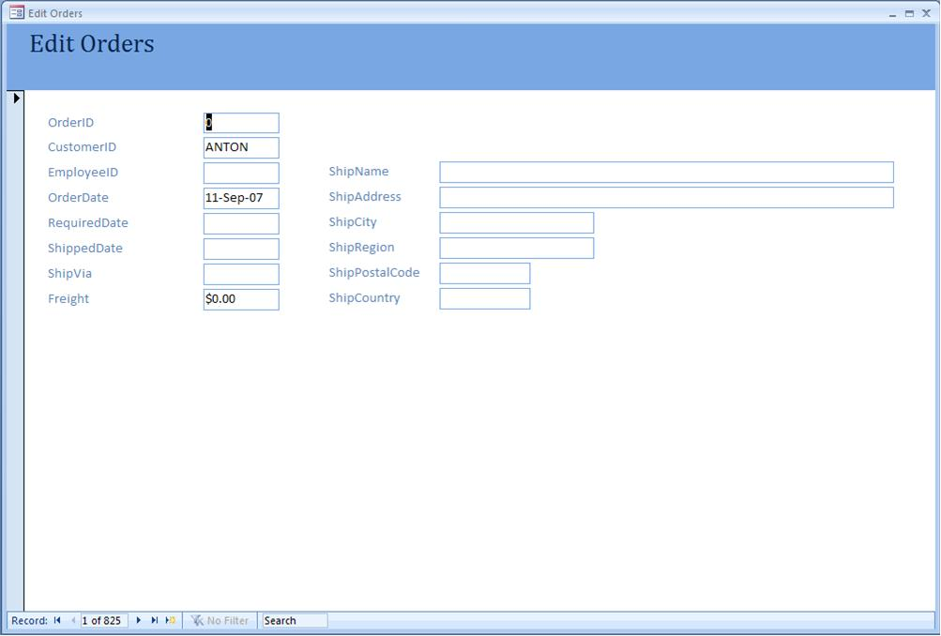

- Now we will add a sub-form to enter and edit information from the Order Details table. Switch to Design View.
- Access provides a wizard for creating sub-forms, which automates many of the steps. First, make sure the wizard is enabled on by making sure the Use Control Wizards icon in the Design Toolbar is highlighted.
- Click the Subform/Subreport tool in the Toolbox. Then click on your form just under the Freight label. The wizard will start.
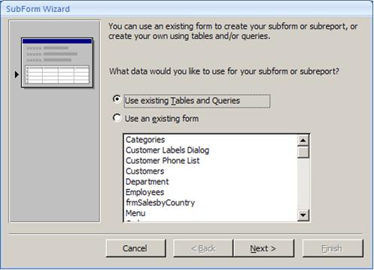
- You can either use an existing (previously created) form for your sub-form or you can use a table or query and have the wizard create a new form for you. Since we don't already have a form to use as our sub-form, select Use existing Tables and Queries. Click Next.
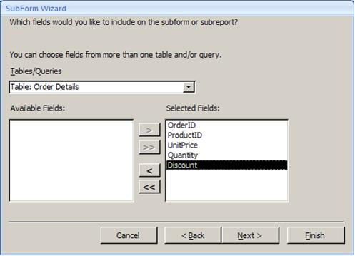
- On the next screen you select which table or query to base the sub-form on and what fields to use. Select the Order Details table and select all fields as shown here. Click Next.
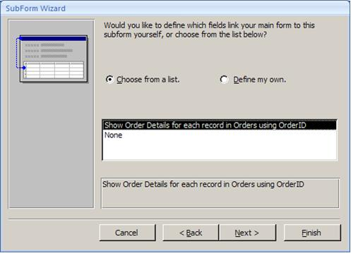
- If we are viewing a particular Order table record, then we want to view with it the Order Details records that go with that same order. Therefore the form and sub-form must be linked together. The next screen of the wizard does this. The wizard almost always selects the correct fields for linking the two tables, in this case the OrderID field in both tables. Click Next.
- On the final wizard screen name the sub-form Order Details Subform and click Finish.
- Resize the sub-form that was created by the wizard to make it about 6 inches wide.
- Click the Form View icon. Your revised form with the sub-form included should look something like what is shown here.

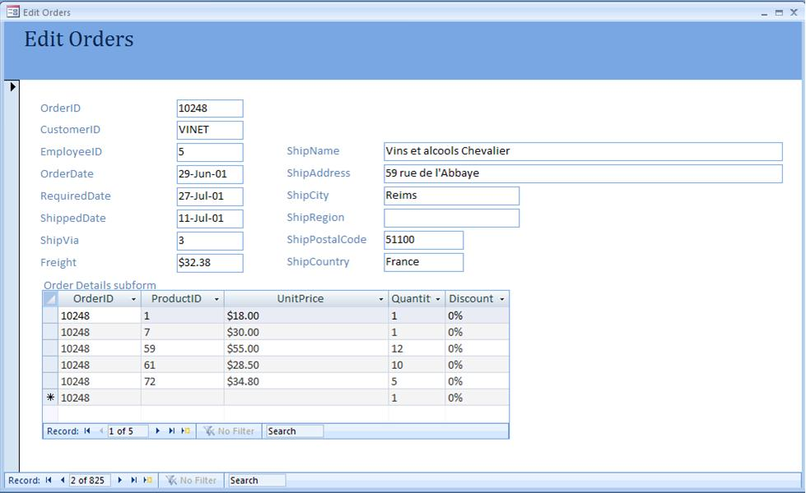

- We will want to modify what the wizard has created, and we can start while in Form View. It is gratifying to see that the main form is currently showing the Order table record for OrderID 10248 while the sub-form is showing the three Order Details table records for OrderID 10248. That means that our form and sub-form were linked correctly. But an end-user doesn't need to see 10248 in every row of the sub-form. Right-click on the OrderID column of the sub-form and select Hide Columns. The column will disappear.
- Position the mouse in the blue bar at the top of the sub-form between the UnitPrice and Quantity columns. The mouse cursor should change to a  shape. Hold down the left mouse button and drag to the left to narrow the UnitPrice column.
- Position the mouse to right of the Quantity column and drag to the right to widen that column so that the entire heading is displayed. Your sub-form should now look like:

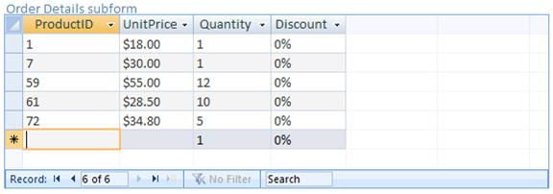

- Now save your form and close it. This is important to do because the column widths will only be saved if you save the form.
- If the Forms are not already being displayed, click the dropdown button at the top of the Database Window and select Forms. Note in the list your Edit Orders form and your Order Details Subform. When the wizard creates a sub-form it creates it as a separate database object. This allows us to edit it directly.
- Open the Order Details Subform and switch to Design View.
- View the Property Sheet for the sub-form. You may need to select Form from the dropdown at the top of the Property Sheet.
- Change the Navigation Buttons property to No. What does this do? Let's see.
- Close and save the form. Then open the Edit Orders form. As you can see here, we have gotten rid of the confusing second set of navigation buttons that previously appeared on the sub-form. Users can still navigate through the records of the sub-form using the scrollbar (when it is needed) and clicking on a record.

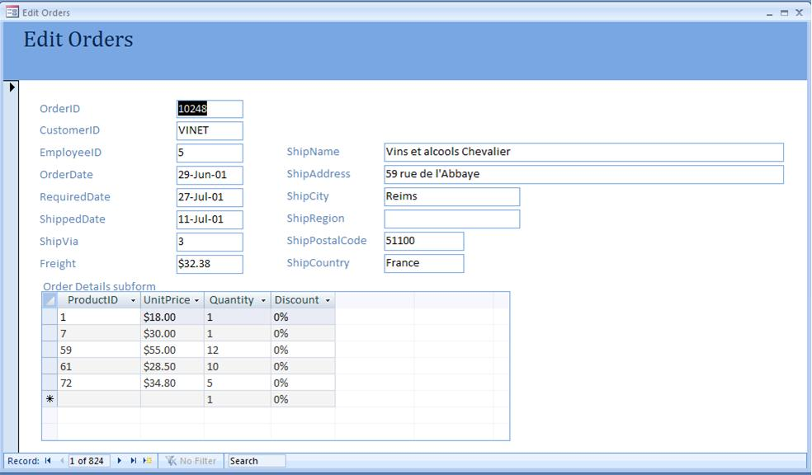

Calculated Text Boxes on Forms
You can place calculated text boxes on a form just as you can with a report. Let's create a calculated extended price textbox in our sub-form.

- Close the Edit Orders form. Again open the Order Details Subform and switch to Design View.
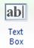
- Resize the form to put more space at the bottom of the Detail band.
- Click on the text box tool in the controls section of the toolbar. Then click in the open bottom area in the Detail band to create the text box there.
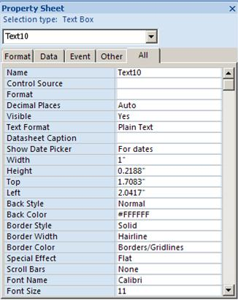
- View the Property Sheet for your new text box.
- Set the Name property to Ext Price.
- Set the Control Source to: =UnitPrice*Quantity*(1-Discount)
- Click into the Format property. Click the dropdown arrow that will appear and select Currency.
- View the Property Sheet for the related label. Change the Caption property to Ext Price. This is what will show as the column heading.
- Save the form.
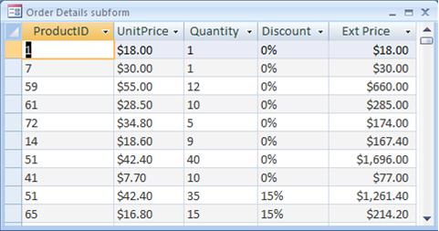
- Click the Datasheet View icon in the lower right corner of the screen. Your revised sub-form should resemble what is shown here. It will look the same inside the main form.

Calculating a total in a Sub-form and displaying it on a Main Form
You can use a form with a sub-form to calculate and display a total for the group of records shown in the sub-form. Let's display a total extended price for the order.

- If the Order Details Subform is not already open, open it.
- Switch to Design View.
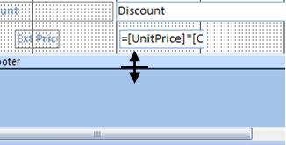
- To calculate the total extended price we need to add a text box to the form footer. We don't currently have a form footer, but we can add it. Position the mouse at the bottom of the gray bar that says Form Footer. The mouse cursor will change to what is shown here.
- Hold down on the left mouse button and drag down until the Form Footer band is large enough to hold a text box.
- Click on the text box tool in the controls section of the toolbar. Then click in the open bottom area in the Form Footer band to create the text box there.
- View the Properties dialog box for your new text box.
- Set the Name property to TotExtPrice. It is important to give it a name that makes sense, because we have to refer to the name later.
- Set the Control Source to: =Sum(UnitPrice*Quantity*(1-Discount)). You'll notice that this is the same as the Ext Price formula we used in our Ext Price column, except that we are using the SQL Sum function to produce a total.
- Since our sub-form displays in Datasheet View (rows and columns), everything in the Form Footer band will be invisible in Form View. But the calculated total will exist and can be mirrored on the main form.
- Save and close the form.
- Open the Edit Orders form and switch to Design View.
- Resize the Detail band of the form so there is enough additional room below the sub-form object for a new text box.
- Click on the text box tool in the Toolbar. Then click in the new open area beneath the sub-form object to create the text box there.
- Select the label that was created with the new text box. View the Properties dialog box and set the Caption property to "Order Sub-Total:"
- Resize the label so that the entire caption will be displayed.
- Select the text box and view its Property Sheet.
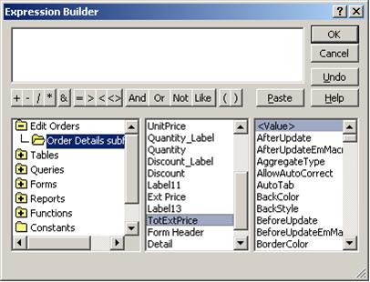
- Click in the Control Source property. Click the Build button on the right side of the Control Source line to launch the expression builder.
- In the pane on the far left, open Edit Orders (our main form) folder, then the Order Details Subform folder.
- The middle pane will now display all the objects on the Order Details Subform. Double-click on TotExtPrice. This will add it to the top pane of the Expression Builder. Then click OK.
- Back in the Property Sheet, set the Name property to OrderSubtotal. Since other calculations may be based on this, it is always a good idea to give your form objects good names.
- Change the Format property to Currency.
- Switch to Form View. Browse the records. You will see the Order Sub-Total change.
- Change the Quantity on an Order Detail row. When you click away from that row you will see the Ext Price for that row change and also the Order Sub-Total.

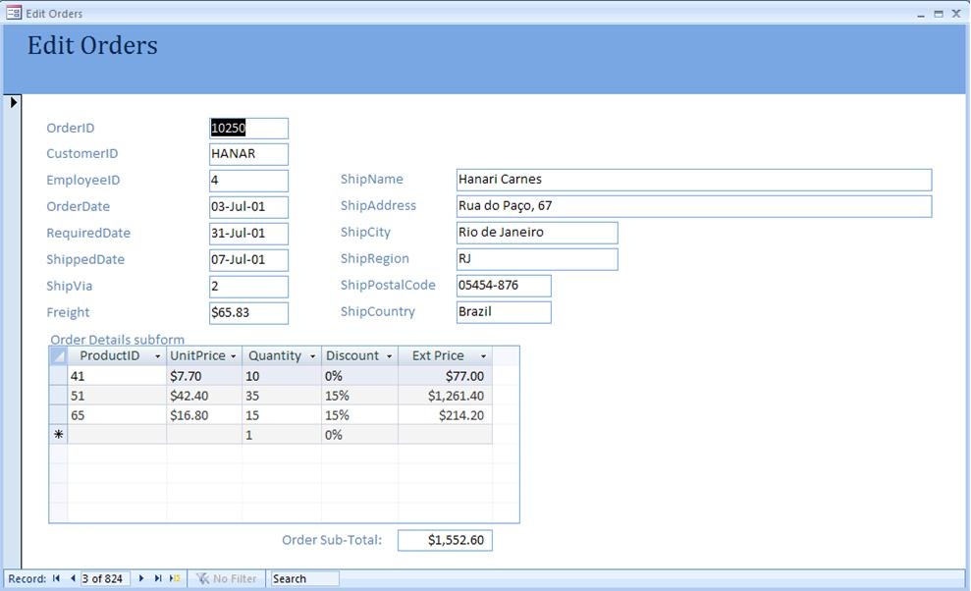

- Close the form, saving your changes.

Form Design Guidelines
The Access Form Wizard can create a form for you. But generally it will not design a form that meets user needs. For that, the following steps are advised.

- Identify system inputs and review logical requirements.
- Select appropriate GUI controls. See the table below that discusses the typical uses for the most common Microsoft Access controls.
- Design, validate, and test inputs using layout tools and/or prototyping tools. Often Access is used as a prototyping tool for forms that will later be coded in another programming environment.
- If necessary, design the source document. A source document is the paper form that is used to capture data for entry into the computer. Of course in many systems the data never goes to a paper form but gets directly entered to computer.

Control | Description & Use | Notes
Text Box | A text box is a box in which a user can type any kind of text.  Should be used when the data input values are unlimited. Examples: Address, Phone Number | - The text box should be large enough for all characters of the data to be entered and viewed by the user. When the length is very long, a scrolling text box should be used.  - A text box should be accompanied by a descriptive, meaningful caption. In Access, captions are created with the Label tool.  - Avoid using abbreviations for captions.  - The first character of the caption's text should be capitalized, and the caption should end with a colon.  - The caption should be located to the left of the text box or left-aligned immediately above it.
List Box  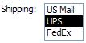 | A list box requires that the user select one choice from a list of possible choices. Several, if not all, choices are displayed at once. If not all can be displayed, the user can scroll to the rest.  Generally should be used when the data input values are:  - Limited  - More than can be shown with radio buttons  - Not so many that the list is unwieldy to scroll through | - A list box should be accompanied by a descriptive, meaningful caption. In Access, captions are created with the Label tool.  - Avoid using abbreviations for captions.  - The first character of the caption's text should be capitalized, and the caption should end with a colon.  - The width of the list box should be large enough for the entire option to be seen.  - The list box should be tall enough to display three to seven choices.  - The order of options should conform to the preferences of the user.
Combo Box  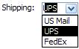 | A combo box includes the capabilities of a text box and a list box. Like a list box, it has a set of possible choices, which are viewed as a drop-down list. The user can select any of those options or type another value. In Access, the ability to type a value not in the list can be turned on or off with the "Limit to List" property. The equivalent "Select control" in web programming always limits choices to the list.  A combo box is appropriate where screen space is too limited for a list box or radio buttons. | - A list box should be accompanied by a descriptive, meaningful caption. In Access, captions are created with the Label tool.  - Avoid using abbreviations for captions.  - The first character of the caption's text should be capitalized, and the caption should end with a colon.  - The width of the list box should be large enough for the entire option to be seen.  - The order of options should conform to the preferences of the user.
Radio Button  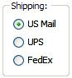 | A radio button is a small circle and an associated description. Radio buttons allow the user to click to select only one of a group of options.  Radio buttons are appropriate when the user needs to select one of a small number of predefined set of options. | - Every radio button should be accompanied by a descriptive, meaningful caption.  - Radio buttons should present the alternatives vertically aligned and left-justified. If necessary, the choices can be presented horizontally aligned provided that adequate spacing is allowed to distinguish which description goes with which radio button.  - The group of mutually-exclusive choices should be grouped and set off from other input controls. In Access this can be easily done using the Option Group tool and its wizard.  - The order of options should conform to the preferences of the user.
Check Box | A check box is a small square and an associated description. Radio buttons allow the user to click to select one or more of a group of options.  Check boxes are appropriate for selections that are either on/off or true/false. With a group of check boxes you can implement a "check all that apply" scenario. | - Every check box should be accompanied by a descriptive, meaningful caption.  - Look for opportunities to group check boxes with a descriptive group heading.  - Generally a group of check box controls should be aligned vertically and left justified.  - The order of options should conform to the preferences of the user.

Key Terms

Check box
Column Count
Column Widths
Columnar form
Combo box
Control Source
Datasheet form
Design View
Expression builder
Form View
Form Wizard
Justified form
Label
List box
Main form
Navigation buttons
Properties
Radio button
Row Source
Sub-form
Tabular form
Text box

Exercises

Your instructor will specify how you are to prepare and submit the answers to the following exercises.

- Create a new tabular form based on the Department table. Modify the wizard-created form in accordance with the Form Design Guidelines listed above.
- Starting on page 11, create and then further modify the Edit Orders form. Be sure to complete ALL steps through page 18, close and save changes.
- Change the CustomerID text box to a combo box. The row source should be an SQL statement that displays from the Customer table the CustomerID and CompanyName. Set the column width property to hide the CustomerID.
- Change the EmployeeID text box to a combo box. The row source should be an SQL statement that displays from the Employees table the EmployeeID and LastName, Firstname both in a single column (Hint: See the note on concatenating text fields in Lab 9). Set the column width property to hide the EmployeeID.
- Create a new columnar form based on the Employees table.
- Size and move the objects as shown below. Make sure each object is large enough to show complete data or the complete label. Align each object horizontally and vertically.
- Add the two line objects as shown.
- Convert the Dept text box to a combo box and have it show the Dept field from the Department table.
- Convert the ReportsTo text box to a combo box. The ReportsTo field relates to another record in the same Employee table. The row source for this combo box should be an SQL statement that displays EmployeeID and LastName, Firstname both in a single column (Hint: See the note on concatenating text fields in Lab 9). Set the column width property to hide the EmployeeID.
- Modify the form in accordance with the Form Design Guidelines listed above.

